VAISHNAVI E 231901059

**EX.NO:3A DATE:**

**SHELL SCRIPT**

**AIM:** To write a Shell script to reverse a given digit using looping statement.

**PROGRAM:**

echo “Enter a number:”

read n reverse=0 while [ $n -ne 0 ]; do remainder=$((n % 10))

reverse=$((reverse * 10 + remainder)) n=$((n / 10)) done

echo “Reversed number: $reverse”

INPUT & OUTPUT:

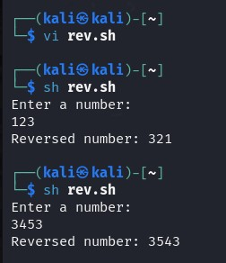

**RESULT:**

Hence, reversing number using shell script is executed successfully.

**CSE-CYBER SECURITY**